use case diagram: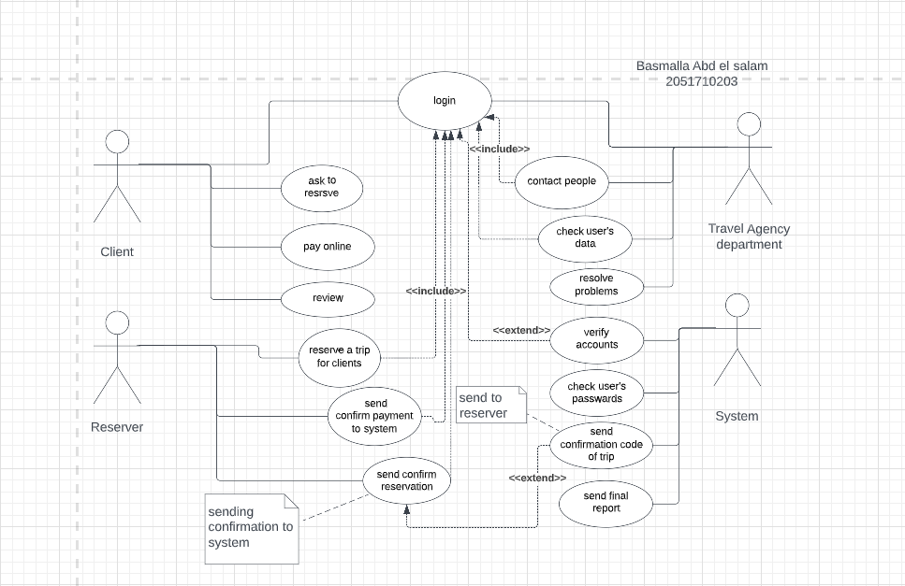

2.7: activity diagram for use case reservation

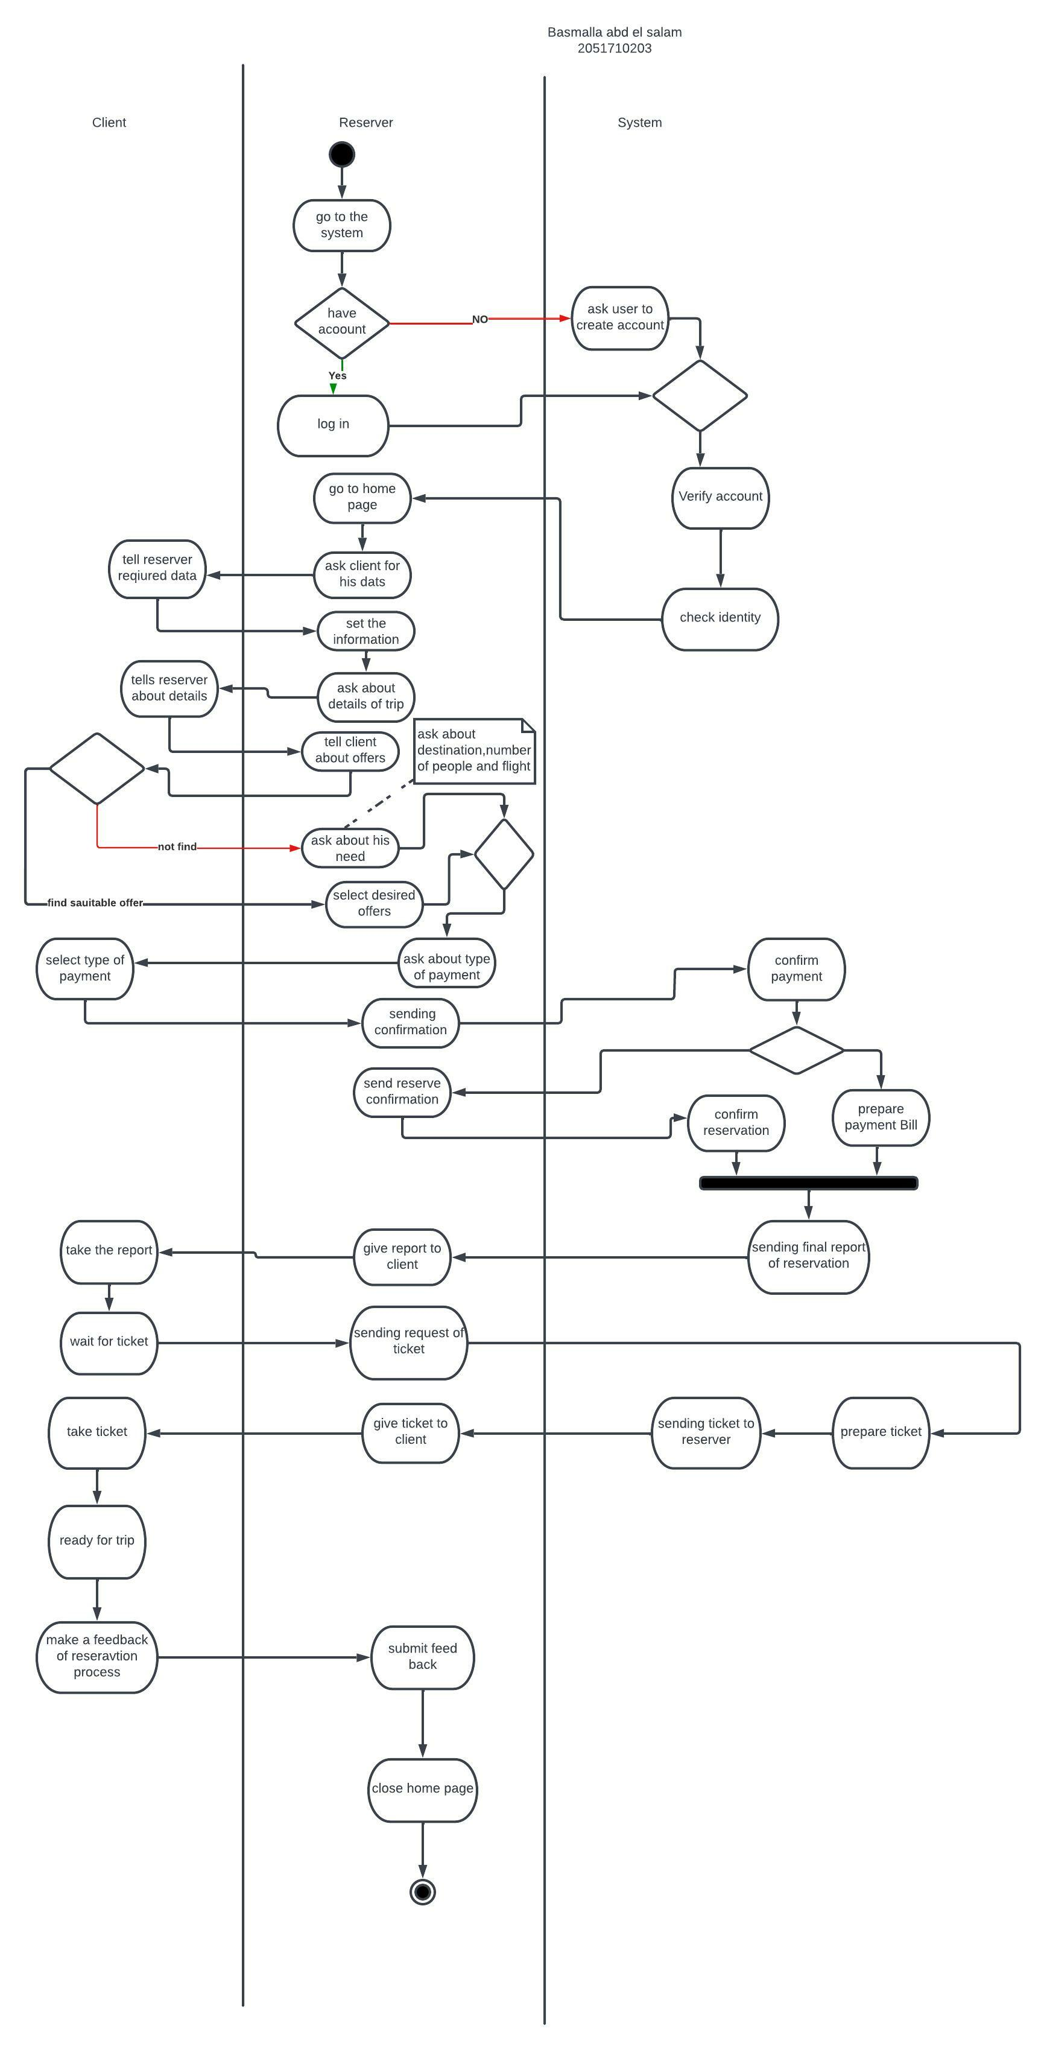

**Draw a class diagram**

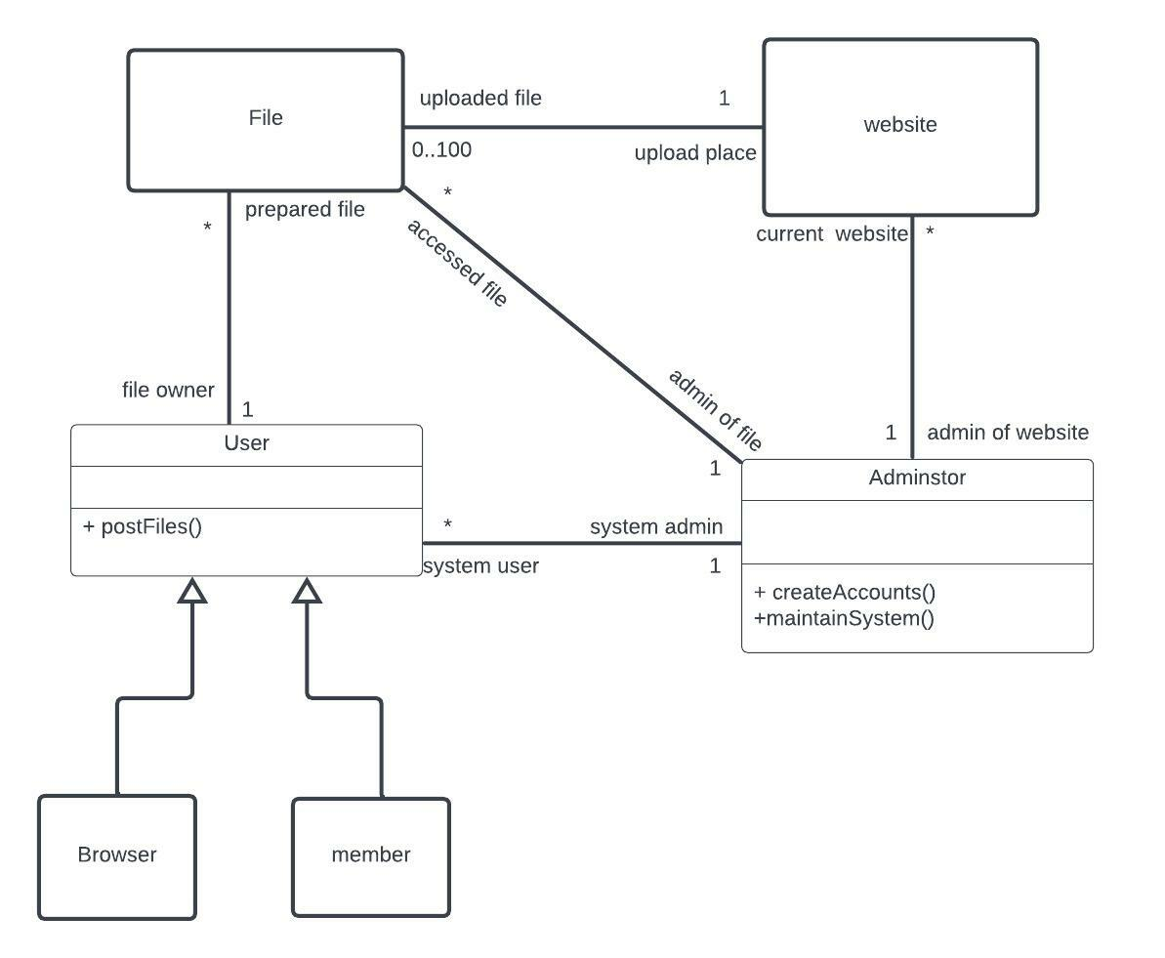

**sequence diagram**



